**Geometry Unit B Part 1: Circles and Composite Area**

Name____________________________________________________Class_________

**Part 1: Circles. SHOW ALL WORK.**

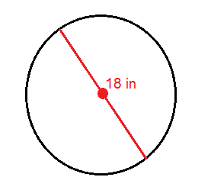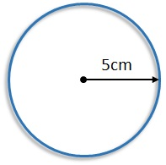Formula for AREA of a circle:*____________________________* Formula for CIRCUMFERENCE:_____________________

1. **Radius = __________ 2. Radius = __________**

**Diameter = ________ Diameter = ________**

**A = __________ A = __________**

**C = ___________ C = ___________**

1. **9.4 mm DIAMETER 4. 3.4 ft. radius**

**Radius = __________ Radius = __________**

**Diameter = _________ Diameter = __________**

**Area = ______________ Area = ______________**

**Circumference = _____________ Circumference = ______________**

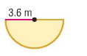**5.** Find the area of the half-circle. **SHOW ALL WORK.**

**A = _____________________**

1. **A pizza has a diameter of 8 inches. Find the area and circumference. Show all work.**

**A = _____________________________ C = ________________________________**

1. **The radius of a birthday cake is 5 cm. Icing will decorate the circumference of the cake. How much icing is needed?**
2. **An area rug has a diameter of 6 feet. How many square feet will the rug cover?**

**Part 2: Composite Figures**

*Instructions: Find the area of the shape. Make sure to include your units and circle your answer.* **(ADD THE AREAS)**

**6.**  *A = $\frac{(b)(h)}{2}$* **7.** *A = $π$ (r)(r)*

*A = (l)(w) A = (l)(w)*

**A=______________ A = ­­­­­­­­­­­­­­­_______________**



**8.**  **9.**

**A = _____________________ A = ____________________**

**Shaded Areas: Find the area of the SHADED REGIONS. (SUBTRACT AREAS.)**

**10.**  **11.**

**A = _______________________ A = _____________________________**

**12.**

**A = _________________________**