Learning Targets

- I can express a linear equation in point-slope form.
- I can graph a linear equation in point-slope form using the slope and y-intercept and my calculator.

Point-Slope Form
$$y-y_{1}=m\left(x-x_{1}\right)$$

Point = (x₁, y₁)
Slope = m

Example: Graph the equation $y-4=\frac{1}{3}(x+6)$
Point:
Slope:

Example: Convert the equation to slope-intercept form
$y-4=\frac{1}{3}(x+6)$

1. Write a point-slope form equation given the following information.

a) A line passes through the point b) A line passes through the point
$(2,5)$ and has a slope of 4. $(-3,1)$ and has a slope of $\frac{1}{2}$.
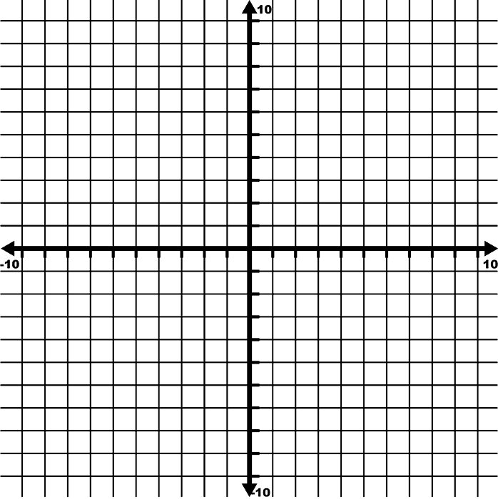
2. Graph the equation.
$y+6=-2(x-3)$

________________ ________________
Point Slope
Connecting the Point-Slope Form to the Slope-Intercept Form
3. Refer back to the example above. Convert the original equation to slope-intercept form. Verify that it is the same line by plotting the y-intercept and graphing using the slope.

Examples (writing equations in point-slope form)
4. Write a point-slope form equation given the following information.
a) A line passes through the points b) A line passes through the points
$(-6, 0)$ and (-2,-3) $(-5,-3)$ and (-6, -4)

Application
5. There is a daily fee for renting a moving truck, plus a charge of $0.50 per mile driven. It costs $64 to rent the truck on a day when it is driven 48 miles.

- Write the point-slope form of an equation to find the total charge y for any number of miles x for a one-day rental.

- Write the equation in slope intercept form.

- What is the daily fee?

Extra Practice Textbook p. 235, #1-9

