Algebra 1 Name: _________________________________
Unit 2.2 Recovery Work Recovery Test DUE by 11/30/18

Functions (Remember to use interval notation when appropriate.)
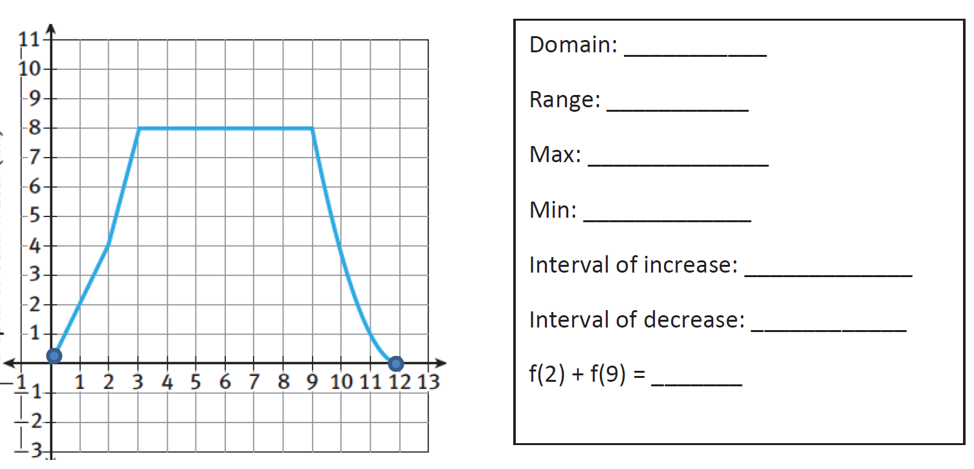

Evaluating Functions

Arithmetic Sequences
Find the Recursive Formula for the following sequences:
- -13, -15, -17, -19… 2. 5, 9, 13, 17…

Other Resources to Study:
Quizizz:
Functions: 439046
Function Notation: 672778
End Behavior: 485931
Arithmetic Sequences: 419470
USA Test Prep: EOC Algebra 1 Resources, Functions Standards 1-4 and 13
Ms. King’s Website, Algebra 1 Extra Resources, Unit 2.2

