Multi-Step Equations Review
Directions: Show All Steps on another sheet of paper.
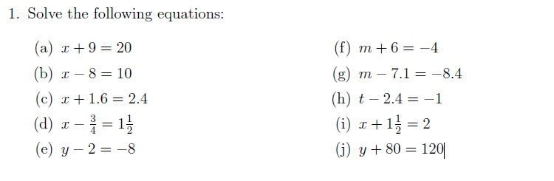
Equations Involving Multiplication
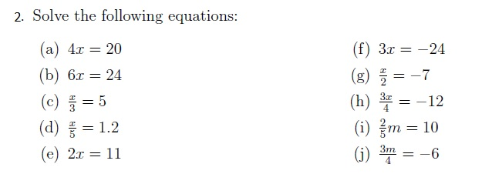
Equations Involving Multiple Terms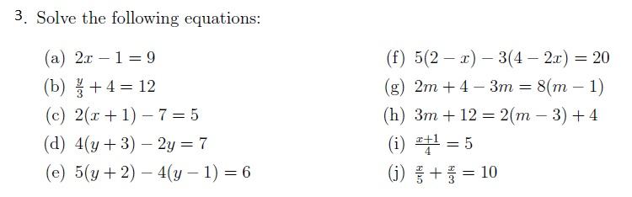

Solving Equations in One Variable
